# Name : Esraa Ashraf Fouad Mahmoud Elsamadony

# B.N : 169

# SEC : 8

# Topic : Cryptography

# GitHub Link :

# GitHub page(published website) :

# Date : 11June2021

TOPIC BRIEF:

* Cryptography is a method of protecting information and communications through the use of codes, so that only those for whom the information is intended can read and process it. The prefix "crypt-" means "hidden" or "vault" -- and the suffix "-graphy" stands for "writing."
* In this report ,I will show you importanat things about cryptography like: its terminology, History of cryptography and cryptanalysis, Modern Cryptography and a lot of cryptographers .

screenshots about the topic from the website:

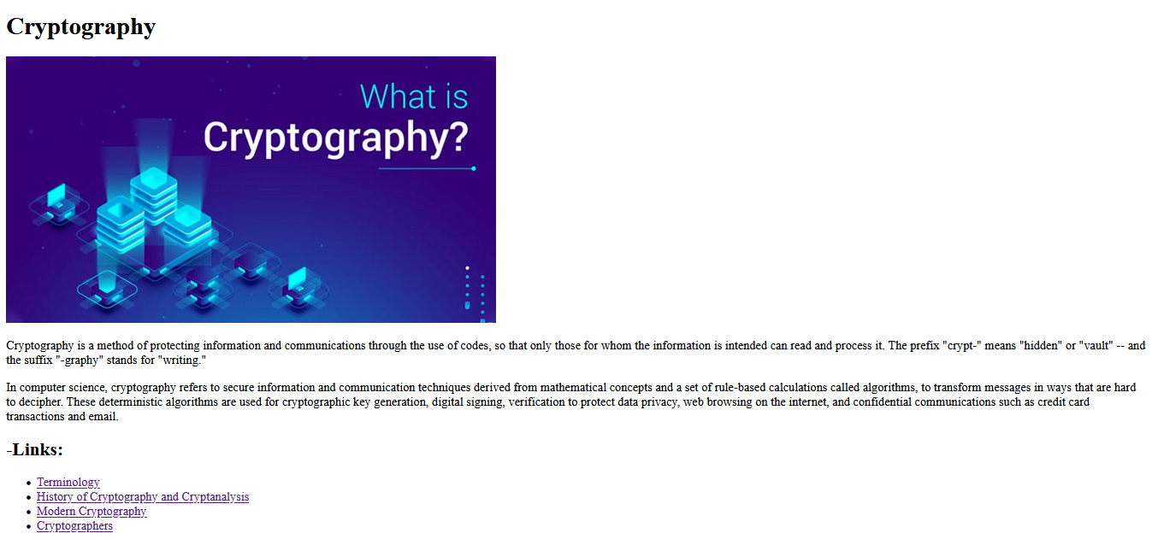

# the main page

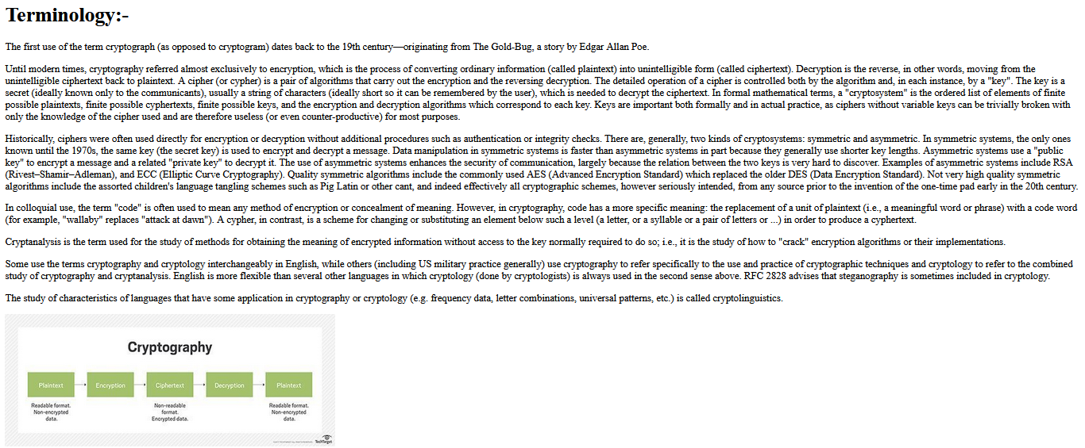

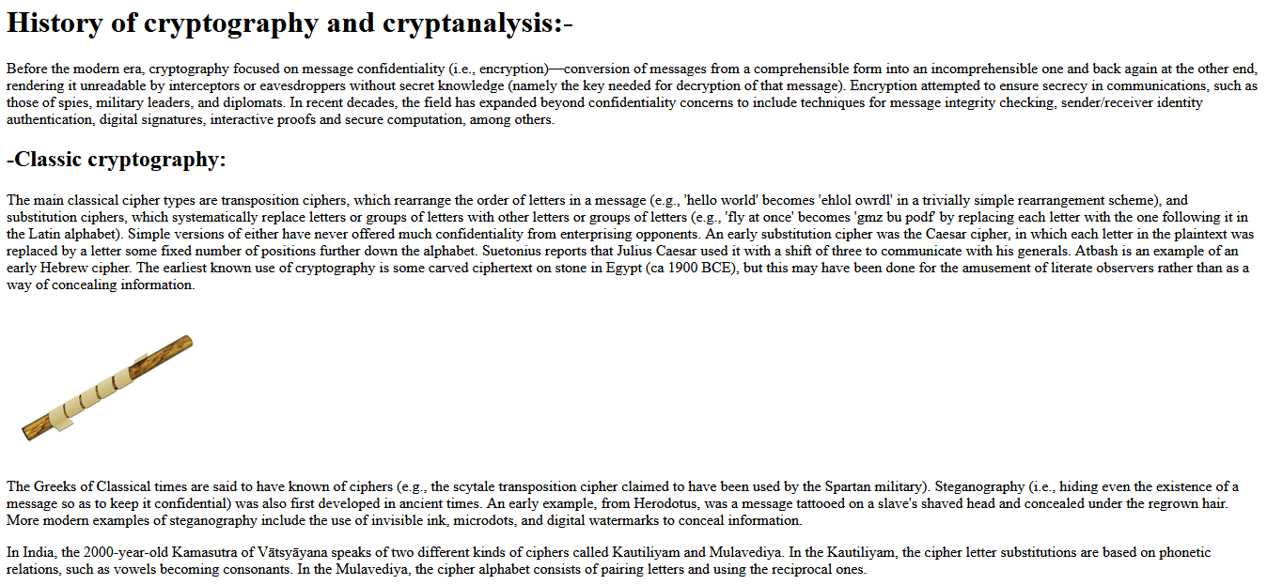

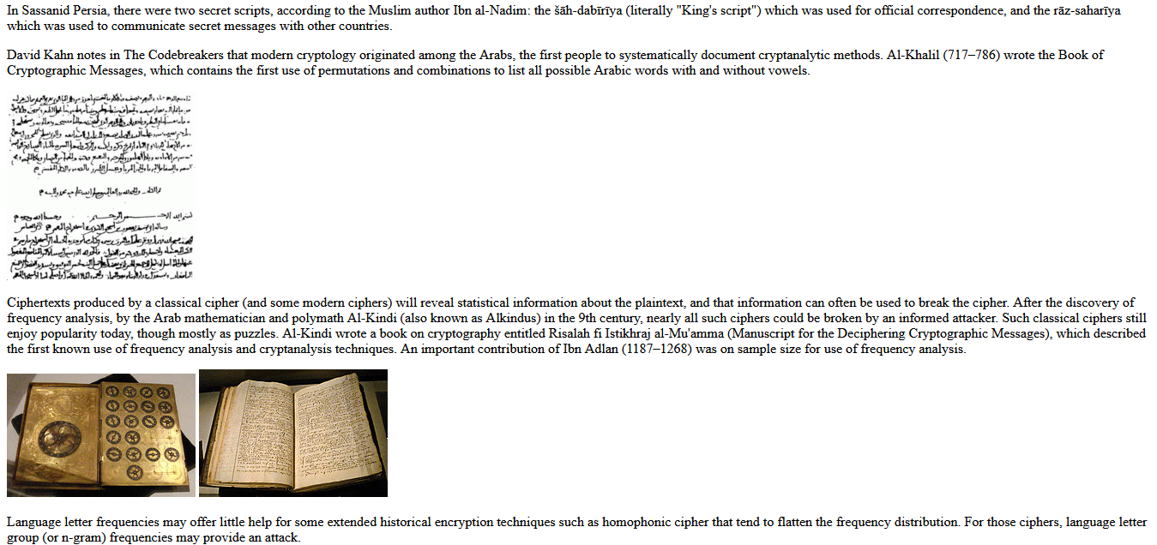

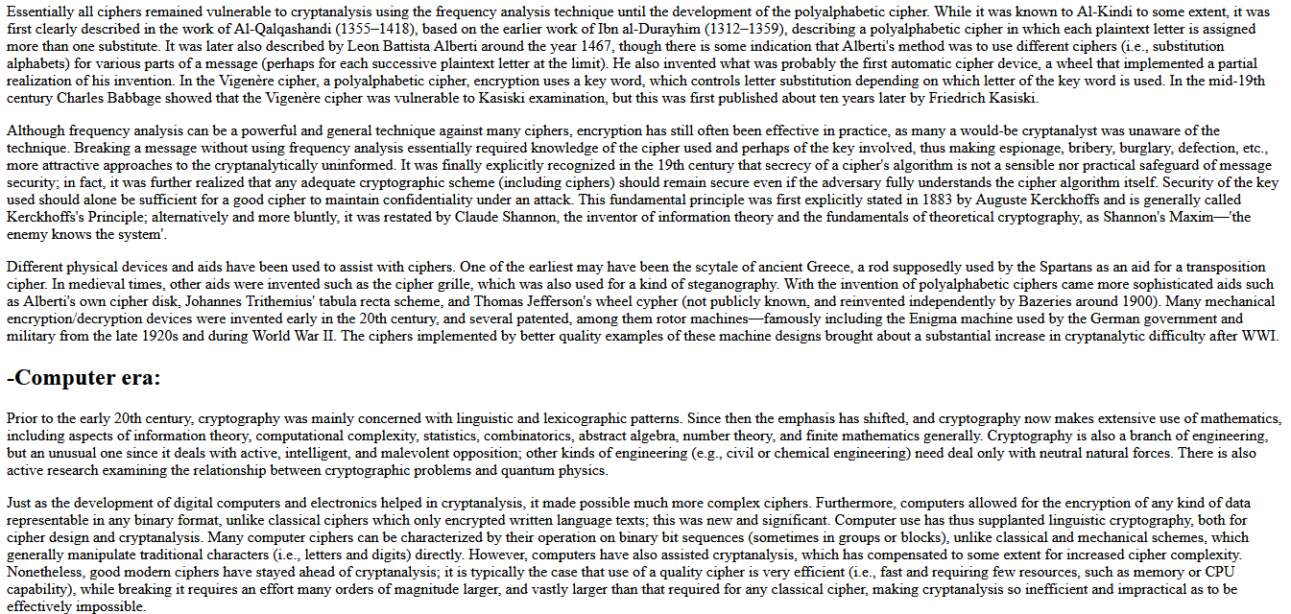

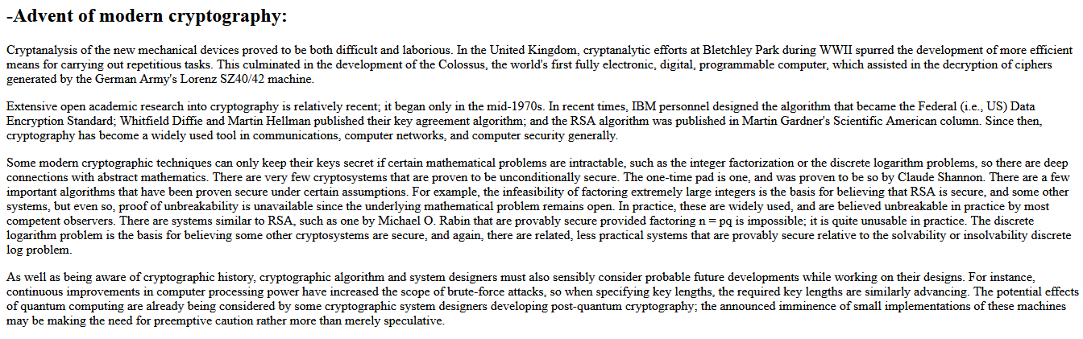

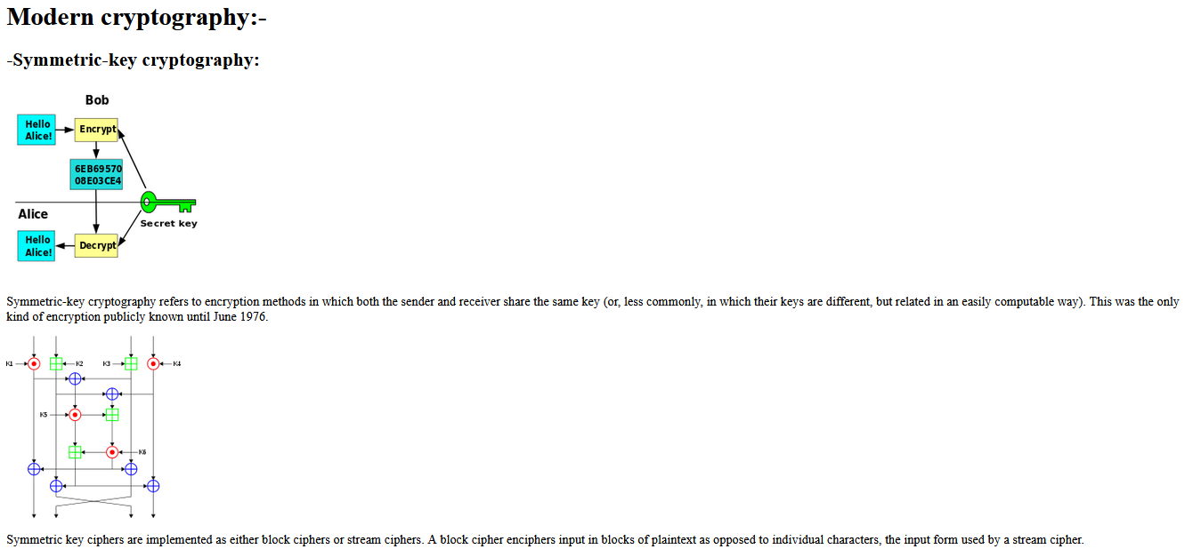

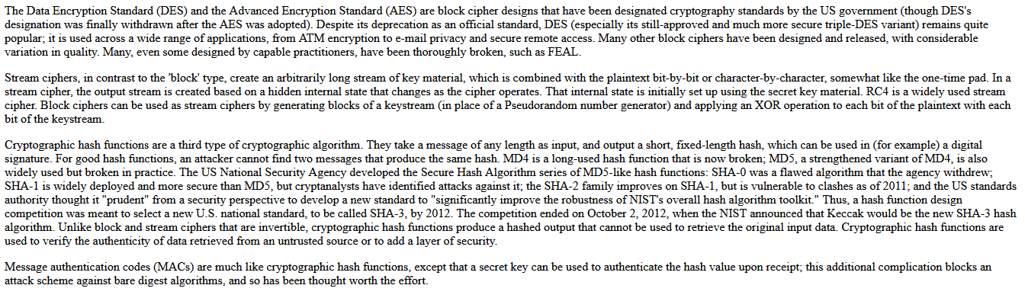

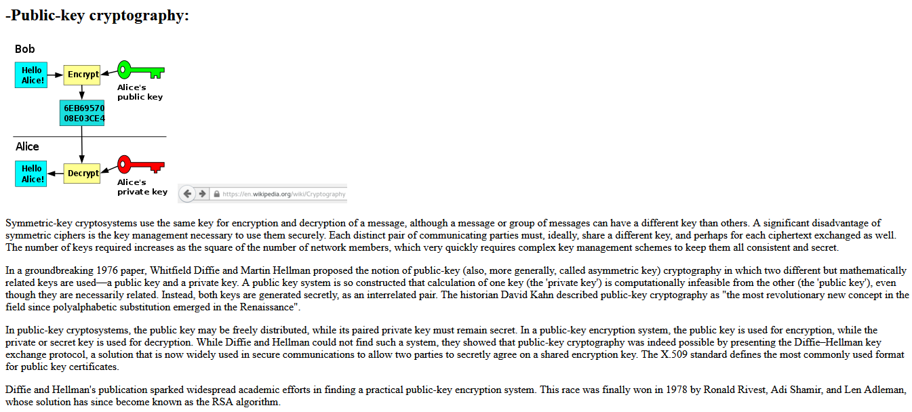

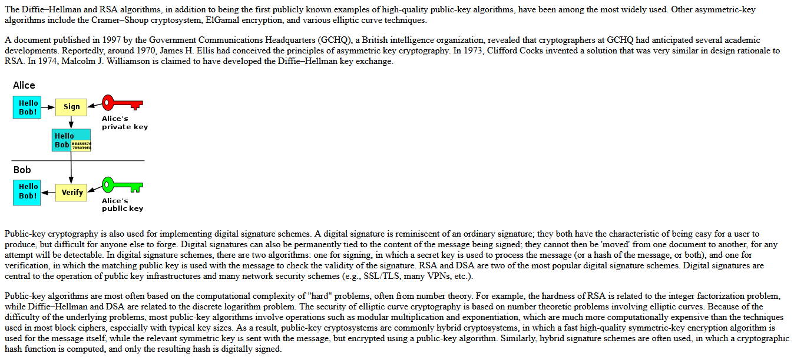

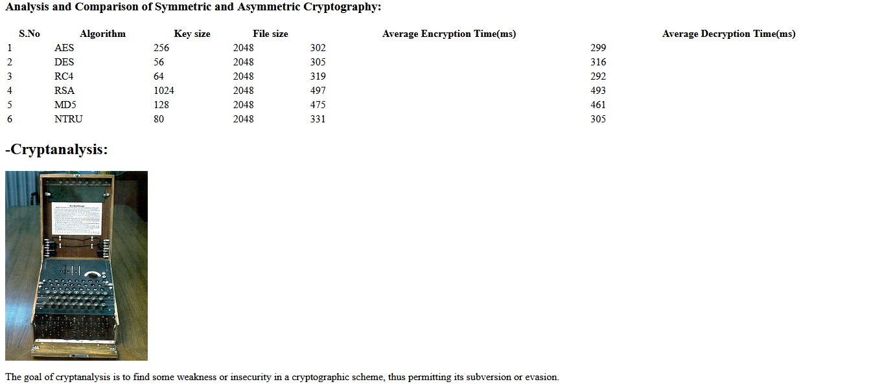

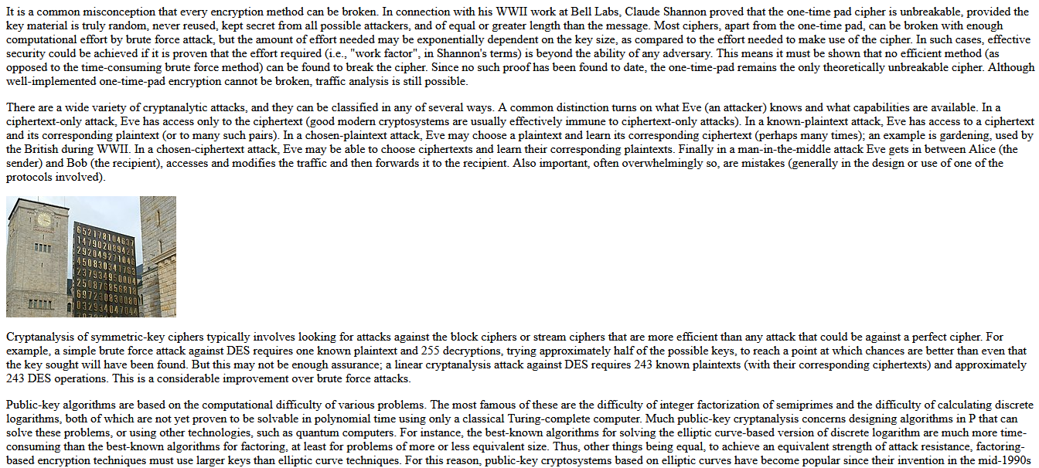

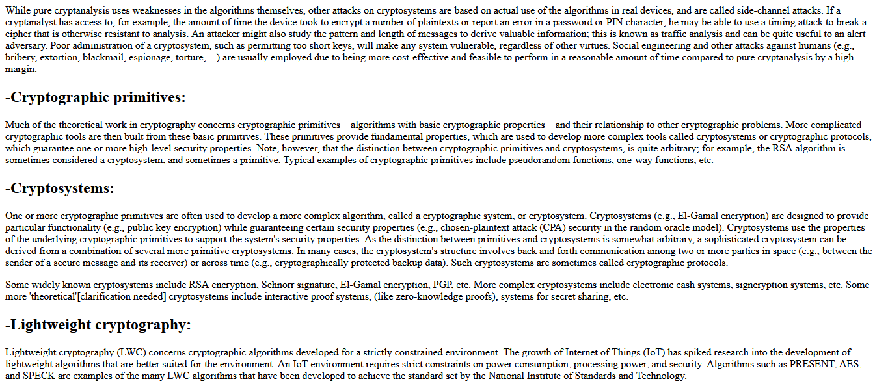

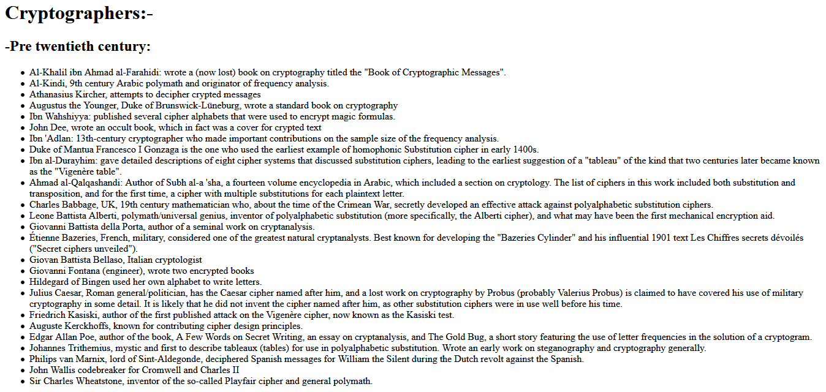

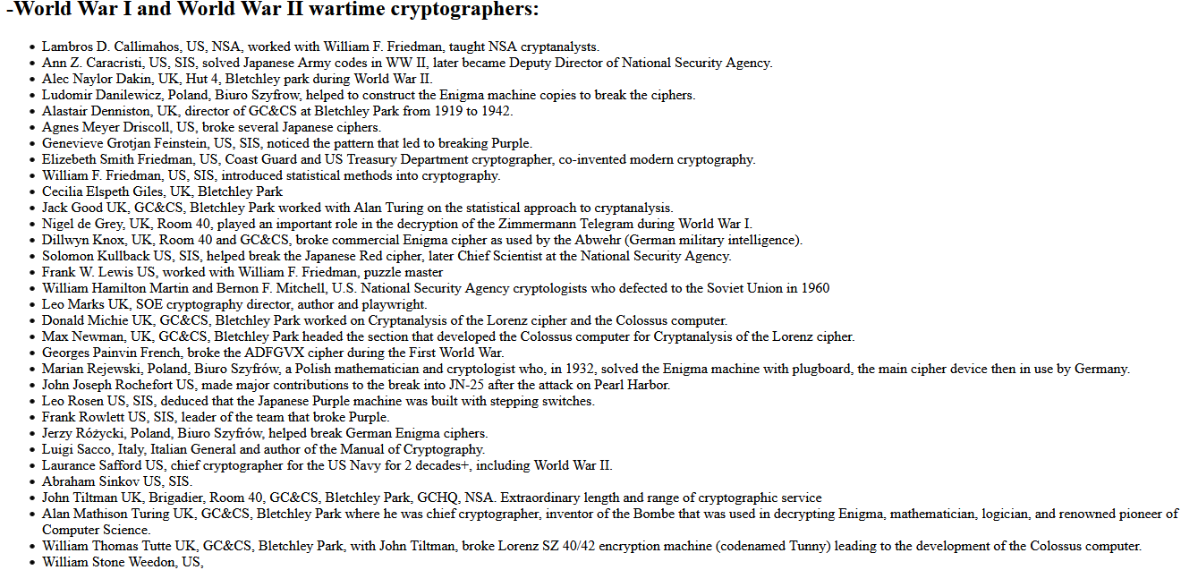

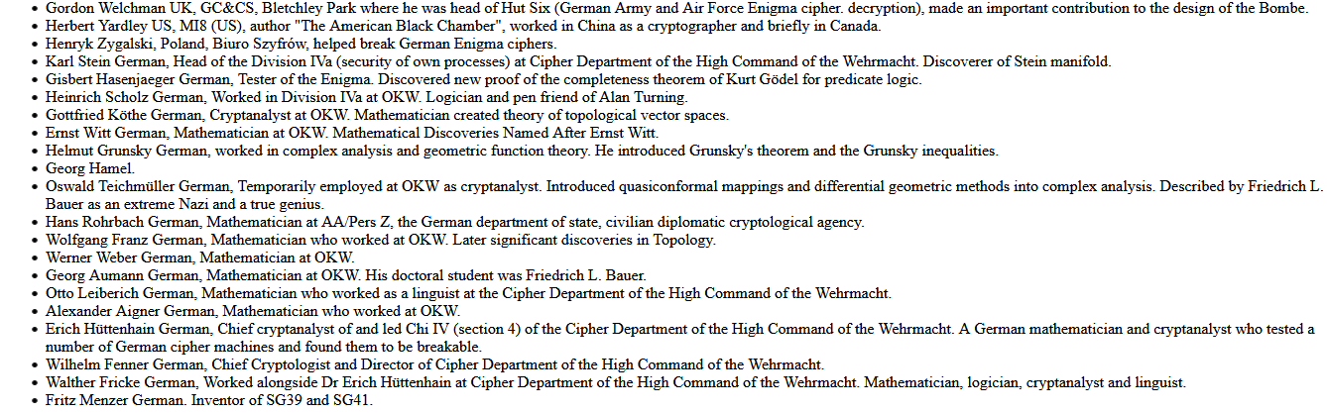

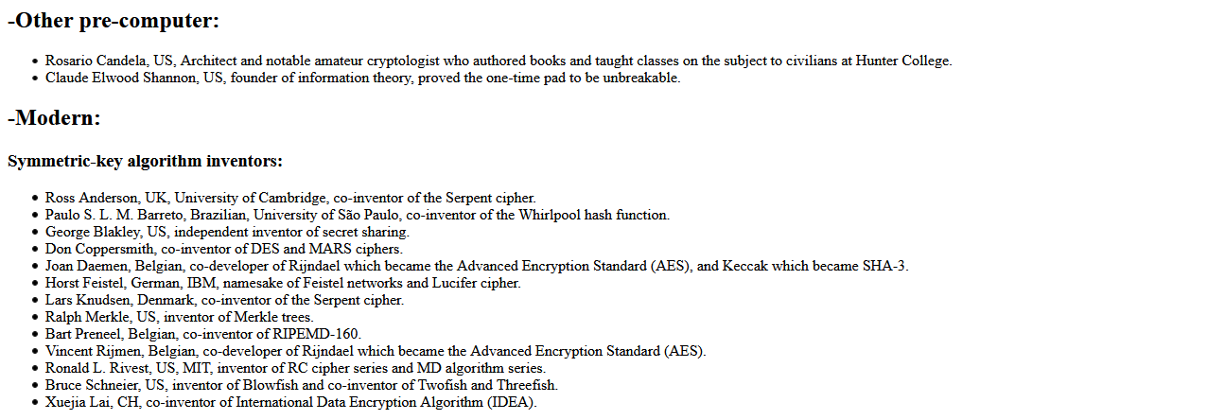

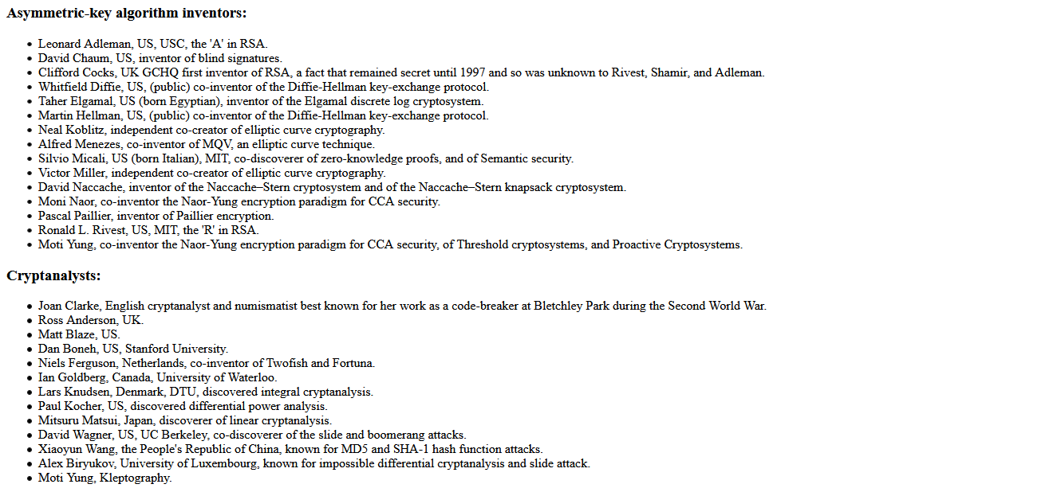

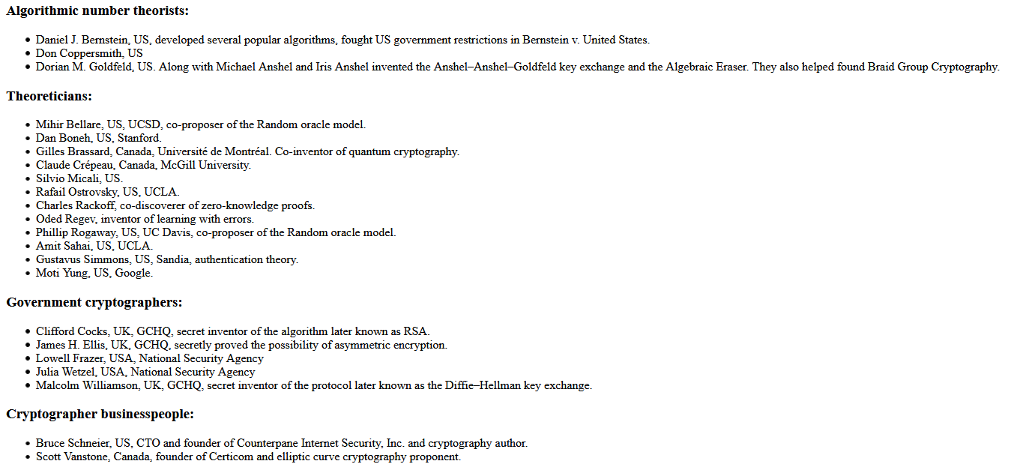

# HTML codes:

